The Economics of Antibiotics - Part 1: Why NICE and NHS England are Testing an Innovative HTA and Payment Model to Tackle Antimicrobial Resistance
Article by: Isobel Firth, Simon Brassel, Mikel Berdud, Adrian Towse and Lotte Steuten
Wednesday, 12 October 2022

https://www.ohe.org/news/economics-antibiotics-part-1-why-nice-and-nhs-england-are-testing-innovative-hta-and-payment

This article was commissioned by Pfizer Inc. Content was written by OHE Consulting Ltd with technical review from Pfizer Inc.
Antibiotics are vital medicines, and it is clear that not enough of them are being developed [1,2]. Novel models to pay for antibiotics have been suggested for many years to incentivise companies to increase their investment in antibiotic development [3]. Recently the UK has become the first country in the world to test a so-called ‘fully delinked model’ to pay for antibiotics [4]. OHE is publishing a series of four blogs to answer the key questions raised by the NICE-NHS England AMR model and discuss what it means for the future of antibiotic development.
What is the antibiotic problem?
Antibiotics are vital medicines that save thousands of lives every day from bacterial infections [5]. But they are becoming less effective [1]. Antibiotic resistance means that the ability of antibiotics to treat bacterial infections is diminishing, a problem made worse by the lack of new antibiotics being developed to replace those whose efficacy is waning [1]. Alarmingly no new classes of antibiotics have been discovered since the 1980s [1]. As a result, we could reach a point where those thousands of lives every day can no longer be saved, and other core areas of modern medicine that rely on our ability to safely treat infections, such as surgery and cancer care, become less and less effective, because of high death rates from the associated infections [6].
Antimicrobial resistance, or AMR, is a broad term encompassing resistance to drugs for infections caused by other microbes such as parasites (e.g. malaria), viruses (e.g. HIV), and fungi (e.g. Candida) [7]. In these blogs, we focus on antibiotic resistance and therefore bacteria, although many of the themes are shared across the wider topic of AMR. Specifically for all technologies under the AMR-umbrella,traditional value assessments do not recognise their true value to society, a topic we will dive into in the rest of this blog series.
Market failure means there are not enough new antibiotics
There are not enough new antibiotics being developed because there is not enough of an incentive for companies to invest in antibiotic development under the traditional model of pharmaceutical innovation and reward [2]. Antibiotics may be riskier to develop than other pharmaceutical products principally because many promising compounds have high toxicity [6]. Once they have been developed, antibiotics are assessed using non-inferiority clinical trials, which can only show whether a new antibiotic is no worse than (or ‘non-inferior’ to) existing antibiotics [2]. Coupled with the fact that many of those existing antibiotics are low-cost generics, companies don’t have the evidence to demonstrate the added clinical value or cost-effectiveness of a novel antibiotic at a price that would generate sufficient returns on investment [2].
It is also difficult for companies to demonstrate the broader value of antibiotics (i.e. the value they generate beyond individual patients) using traditional models of value assessment. The benefit of reducing resistance, preventing transmission of pathogens, and enabling other medical procedures to take place are all part of the potential value profile for a new antibiotic. However, this broader value is not considered within the traditional value assessment processes that are used to establish prices for medicines. As a result, prices for antibiotics, and therefore the rewards for innovation, do not reflect the true value of antibiotics, further weakening incentives [2].
If antibiotics do reach the market they are often used sparingly. This is because of antibiotic stewardship principles, which aim to limit the inappropriate use of antibiotics to slow down the build-up of resistance. The expected sales volumes for any novel antibiotic are therefore low. Low volumes sold at low prices have led many large pharmaceutical companies to leave the antibiotics space and have bankrupted a number of smaller antibiotic companies [2,8].
Health economists have developed a mechanism to strengthen incentives for antibiotic Development
Health economists, recognising the antibiotic market’s failure, have proposed the ‘delinked model’ - a particular form of pull incentive designed to give companies a reason to invest [9]. A pull incentive draws innovation to the market with the promise of reward for successful innovators that is not linked to the number of antibiotics used [9]. In many disease areas, the ‘pull’ is the market itself, which is large enough to sustain innovation, but where there is a market failure, the pull incentive has to be designed outside of the market to generate the same willingness to invest from the industry [9].
The delinked pull incentive model breaks the link between rewards and the volume sold and can be implemented in various ways [9]. One option is the so-called subscription or ’Netflix' model initially implemented in Louisiana to encourage the uptake of hepatitis C treatments [10,11]. Under a subscription model companies developing antibiotics are paid through a subscription fee in the same way people pay monthly for services like Netflix or Spotify. As with Netflix, where the monthly payment is the same regardless of how many films you stream, the subscription fee for antibiotics is set and ’delinked' from the volumes of antibiotics used in the health system [10].
The benefit of the delinked model for companies is that they have certainty about the revenue they will generate if they develop an effective antibiotic [2]. If the aggregated global subscription fees are large enough, it should attract companies to invest in antibiotic development by generating a high enough global revenue. We will cover how big the pull incentive should be to stimulate innovation in a future blog in the series [2].
Recent initiatives from NICE and NHS England have put the theory of a delinkage into practice
In 2020 the UK became the first country in the world to trial the use of the delinked model for paying for antibiotics [4]. The NICE-NHS England AMR (antimicrobial resistance) model trialled a subscription model for two antibiotics for serious infections resistant to the last line of antibiotics [3]. The subscription fee was linked to a broader value assessment conducted by NICE to account for the value of antibiotics beyond the value to the individual patient [3].
The results for both products, published in April this year, marked a huge step forward in validating the concept of a delinked subscription model to pay for antibiotics. The model, if expanded globally, has the potential generate a pull incentive that would overcome the market failure of antibiotics [4]. Both companies participating in the pilot were satisfied with the result, and many experts on antibiotic resistance hailed it as a success in turning health economic theory into practice [12].
Below the surface of the shared optimism, however, questions remain. What does the pilot mean for future antibiotics in the UK? Could a similar delinked model be implemented in enough countries to generate an effective pull incentive on a global level? Is a delinked model really the silver bullet needed to tackle the crisis of antibiotic resistance?
Our blog series lifts the lid on the economics of antibiotic development
Our blog series The Economics of Antibiotics discusses the economics of antimicrobial resistance to understand the relevance of the NICE-NHS England AMR model. The next three blogs explore the questions that remain about the delinked model:
- Part 2: Value Assessment within the NICE-NHS AMR Pilot
- Part 3: Creating a Healthy Global Market for New Antibiotics
- Part 4: What Does the Antibiotics Market of the Future Look like?
Related OHE research
Neri, M., Hampson, G., Henshall, C. and Towse, A. (2019) HTA and Payment Mechanisms for New Drugs to Tackle AMR. OHE Research Paper. Available from https://www.ohe.org/publications/hta-and-payment-mechanisms-new-drugs-tackle-amr.
Ferraro, J., Towse, A., and Mestre-Ferrandiz, J. (2017) Incentives for New Drugs to Tackle Anti-Microbial Resistance. OHE Briefing. Available from https://www.ohe.org/publications/incentives-new-drugs tackle-anti-microbial-resistance.
Sharma, P. and Towse, A. (2011) New Drugs to Tackle Antimicrobial Resistance: Analysis of EU Policy Options. OHE Monograph. Available from https://www.ohe.org/publications/new-drugs-tackle antimicrobial-resistance-analysis-eu-policy-options.
References:
- Wellcome Trust, 2020. Why is it so hard to develop new antibiotics? [online] Wellcome. Available at: https://wellcome.org/news/why-is-it-so-hard-develop-new-antibiotics [Accessed 30 Jun. 2022].
- Payne, D.J., Miller, L.F., Findlay, D., Anderson, J. and Marks, L., 2015. Time for a change: addressing R&D and commercialization challenges for antibacterials. Philosophical Transactions of the Royal Society B: Biological Sciences, 370(1670), p.20140086. 10.1098/rstb.2014.0086.
- NICE, 2022. NICE reaches important milestone in the UK’s efforts to tackle antimicrobial resistance. | News and features | News | NICE. [online] Available at: https://www.nice.org.uk/news/article/nice-reaches-important-milestone-in... tackle-antimicrobial-resistance [Accessed 30 Jun. 2022].
- Perkins, M. and Glover, D., 2020. How the ‘NHS model’ to tackle antimicrobial resistance (AMR) can set a global standard. Available at: https://www.england.nhs.uk/blog/how-the-nhs-model to-tackle-antimicrobial-resistance-amr-can-set-a-global-standard/ [Accessed 8 Sep. 2022].
- Ventola, C.L., 2015. The Antibiotic Resistance crisis: Part 1: Causes and Threats. P & T : a peer reviewed Journal for Formulary Management, [online] 40(4), pp.277–83. Available at: https://www.ncbi.nlm.nih.gov/pmc/articles/PMC4378521/.
- Prasad, N.K., Seiple, I.B., Cirz, R.T. and Rosenberg, O.S., 2022. Leaks in the Pipeline: a Failure Analysis of Gram-Negative Antibiotic Development from 2010 to 2020. Antimicrobial Agents and Chemotherapy, 66(5), p.e0005422. 10.1128/aac.00054-22.
- WHO, 2022. What is the difference between antibiotic and antimicrobial resistance? [online] World Health Organization - Regional Office for the Eastern Mediterranean. Available at: http://www.emro.who.int/health-topics/drug-resistance/what-is-the-differ... antibiotic-and-antimicrobial-resistance.html [Accessed 30 Jun. 2022].
- Taylor, N., 2020. Melinta files for bankruptcy in another dark day for antibiotics. [Fierce Biotech] Available at: https://www.fiercebiotech.com/biotech/melinta-files-for-bankruptcy-anoth... day-for-antibiotics [Accessed 11 Jul. 2022].
- Cama, J., Leszczynski, R., Tang, P.K., Khalid, A., Lok, V., Dowson, C.G. and Ebata, A., 2021. To Push or To Pull? In a Post-COVID World, Supporting and Incentivizing Antimicrobial Drug Development Must Become a Governmental Priority. ACS Infectious Diseases. doi:10.1021/acsinfecdis.0c00681.
- Trusheim, M.R., Cassidy, W.M. and Bach, P.B., 2018. Alternative State-Level Financing for Hepatitis C Treatment-The ‘Netflix Model’. JAMA, 320(19), pp.1977–1978. 10.1001/jama.2018.15782.
- Sood, N., Ung, D., Shankar, A. and Strom, B.L., 2018. A Novel Strategy for Increasing Access to Treatment for Hepatitis C Virus Infection for Medicaid Beneficiaries. Annals of Internal Medicine, 169(2), pp.118–119. 10.7326/M18-0186.
- Rex, J.H., 2022. UK Pull (Netflix) pilot: QALY value of new antibiotics implies societal value >10m GBP/year! AMR.Solutions. Available at: https://amr.solutions/2022/04/11/uk-pull-netflix pilot-qaly-value-of-new-antibiotics-implies-societal-value-10m-gbp-year/ [Accessed 11 Jul. 2022

The Economics of Antibiotics - Part 2: Value Assessment within the NICE-NHS AMR Pilot
Article by: Simon Brassel, Isobel Firth, Mikel Berdud, Adrian Towse and Lotte Steuten
Wednesday, 12 October 2022

https://www.ohe.org/news/economics-antibiotics-part-2-value-assessment-within-nice-nhs-amr-pilot

This article was commissioned by Pfizer Inc. Content was written by OHE Consulting Ltd with technical review from Pfizer Inc.

The first blog in this series on the economics of antibiotics explained why markets fail to incentivise the development of novel antibiotics. It also outlined how England has spearheaded efforts to test a potential solution to this challenge through a subscription model for antibiotics in the NICE-NHS England AMR pilot. This second blog focuses on the value assessment used within the NICE-NHS England AMR pilot, which is crucial for capturing an antibiotic’s value so the subscription model can reward those with higher value.

Trying to change the rules of the game

The Health Technology Assessment (HTA) model has been used in England for decades to assess the value of medicines and decide whether or not the NHS will pay for them [1]. The first problem with the reimbursement of antibiotics is that HTA, as it is traditionally carried out, uses methods that are inappropriate for antibiotics leading to their undervaluation, subsequent low prices and weak incentives for developers [2]. The second problem is that a payment mechanism by the NHS based on volume-linked reimbursement can compromise existing and future antibiotic stewardship- that aims to limit inappropriate use of antibiotics and therefore, in some way; limit the volumes of antibiotics used [3].

There are various methodological shortcomings of traditional HTA when applied to antibiotics, such as the choice of a single comparator instead of the more complex reality in which a diversity of products is used; the use of health-economic models don’t fully capture transmission effects or the impact of growing resistance over time; and the focus on narrow benefits to patients treated with a specific antibiotic while ignoring several important wider population effects, prevent to capture the broader value of antibiotics to society appropriately [4].

In recognition of the shortcomings of traditional HTA, the NICE-NHS England AMR pilot aimed to improve on the status quo with a new HTA method specifically designed to capture such broader value of antibiotics [5]. By combining this novel HTA approach with the subscription-based payment model it is possible to create a procurement mechanism that is in line with good antibiotic stewardship [3].

Ready, STEDI, Go

The AMR model’s HTA process is based on a novel value assessment framework for antibiotics proposed by Rothery et al. [6] following work by OHE [4]. One of its most apparent differences compared to the status quo is the introduction of five novel (‘STEDI’) value elements (a term adopted by Outterson and Rex [7]) to capture the broader value of antibiotics summarised in the image below adapted from the definitions used by Karlsberg-Schaffer [4] and Rothery et al.[6].

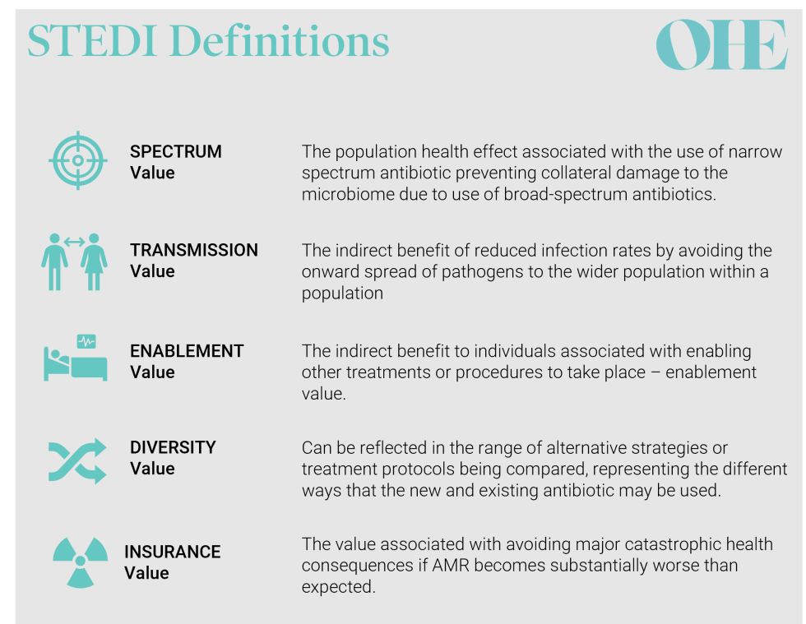

The introduction of the STEDI elements is a game-changer. Similar concepts have been proposed for other health technologies, such as vaccines or advanced medicinal therapeutical products like gene therapies. But STEDI has become the first broader value framework that has been agreed by payers and HTA bodies and implemented in practice.

Why STEDI is challenging to implement

Considering these broader value elements is necessary to capture the value of antibiotics but the pilot showed that measuring each value element appropriately is challenging.

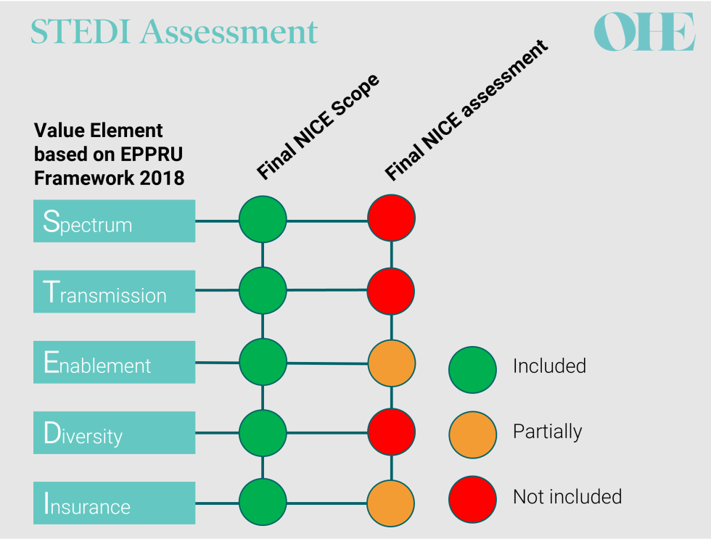
EEPRU recommendations compared to NICE final assessment for both products included in the pilot [8-11]

All parties agreed that neither of the antibiotics in the pilot produced spectrum value because they were both broad-spectrum antibiotics [8,9]. However, opinions differed on the other STEDI elements. The health economic models used by NICE’s commissioned modelling team captured only two of the other STEDI value elements – and even then, only partially. The stated reasons for this included large structural uncertainty (e.g. related to structural modelling choices) and/or lack of relevant evidence contributing to parameter uncertainty [8,9].

Importantly, NICE’s decision-making committee substantially adjusted the valuation for both products to account for missing enablement, diversity and insurance values. The committee also adjusted the valuation because it considered that both antibiotics serve a larger population than was modelled. These two adjustments increased the valuation by 20% and 50% for each of the antibiotics included in the pilot [8,9].

The value of both products after the adjustments by the NICE committee exceeded the capped annual payment set out by the NHS (which will be explained in detail in the next blog). However, the valuation may well have underestimated the true value of both products due the uncertainty in defining the right population size and in capturing the full STEDI value [8,9].

What’s next for the value assessment of antibiotics?

The pilot exposed the opportunities and challenges that lay ahead for the value assessment of antibiotics. All stakeholders should focus on improving the underlying value assessment methodologies. A value assessment process that requires the NICE committee to guesstimate important value elements is not a sustainable approach. Any future value assessments using STEDI must ensure that the underlying modelling provides credible value estimates, for example, by using dynamic transmission models to capture transmission effects, such as is done for vaccines.

Even with the best model in the world, the valuation would still have been limited by a lack of data: a challenge the NICE committee also recognised in its recommendations for further research. Importantly, it recommended improving data collection on the relationship between usage scenarios for antibiotics and the rate of emergence of resistance8,9. The emergence of resistance over time is a crucial component underlying all the STEDI elements and is likely to require significant investment into methods and infrastructure to measure8,9.

There’s also room for improvement in the process before any evidence is assessed. Pfizer developed and submitted their own model for their product that covered both the traditional (patient and health system) value and attempted to capture larger parts of STEDI elements. However, NICE relied almost entirely on the model commissioned from the Policy Research Unit in Economic Evaluation of Health and Care Interventions (EEPRU) for its conclusions8,9. Since modelling the value of an antibiotic over time is complex and resource-intensive, such redundancy should be avoided. It might be preferable to shift the process towards something closer to a technology appraisal, where the company submits the model which is then reviewed by an External Assessment Centre with appropriate expertise. In doing so, NICE could focus on developing suitable methods for modelling the STEDI elements, choosing alternative antibiotic use scenarios, and estimating health effects from microbiological data, so setting the rules which will guide the ’company’s submission.

The elephant in the room: will it even work?

What is clear is that HTA for antibiotics is still developing. With a novel model to assess and pay for new antibiotics England took an essential first step. Even if we manage to overcome all of the uncertainties with the new HTA model, there is still the question of whether the delinked subscription model will be enough to stimulate the global pharmaceutical market? We consider this question in the next blog in our series.

The Economics of Antibiotics blog series

In this four-part series, we discuss the economics of antimicrobial resistance to understand the relevance of the NICE-NHS England AMR model and explore the questions that remain about the delinked model:
- Part 1: Why NICE and NHS England are Testing an Innovative HTA and Payment Model to Tackle AMR
- Part 2: Value Assessment within the NICE-NHS AMR Pilot
- Part 3: Creating a Healthy Global Market for New Antibiotics
- Part 4: What Does the Antibiotics Market of the Future Look like?

References

- Anderson, M., Drummond, M., Taylor, D., McGuire, A., Carter, P. and Mossialos, E., 2022. Promoting innovation while controlling cost: The UK’s approach to health technology assessment. Health Policy, 126(3), pp.224–233. doi:10.1016/j.healthpol.2022.01.013.
- Payne, D.J., Miller, L.F., Findlay, D., Anderson, J. and Marks, L., 2015. Time for a change: addressing R&D and commercialization challenges for antibacterials. Philosophical Transactions of the Royal Society B: Biological Sciences, 370(1670), p.20140086. 10.1098/rstb.2014.0086.
- HM Government. UK 5-year action plan for antimicrobial resistance 2019 to 2024. Available at: https://www.gov.uk/government/publications/uk-5-year-action-plan-for-ant.... [Accessed September 2022].
- Karlsberg Schaffer, S., West, P., Towse, A., Henshall, C., Mestre-Ferrandiz, J., Masterson, R. and Fischer, A., 2017. Additional Elements of Value for Health Technology Assessment Decisions. Briefings. [online] Office of Health Economics. Available at: https://ideas.repec.org/p/ohe/briefg/001851.html [Accessed 17 Jul. 2018].
- NICE, 2022. NICE reaches important milestone in the UK’s efforts to tackle antimicrobial resistance. | News and features | News | NICE. [online] Available at: https://www.nice.org.uk/news/article/nice-reaches-important-milestone-in... [Accessed 30 Jun. 2022].
- Rothery, C., Woods, B., Schmitt, L., Claxton, K., Palmer, S. and Sculpher, M., 2018. FRAMEWORK FOR VALUE ASSESSMENT OF NEW ANTIMICROBIALS. Implications for alternative funding arrangements for NICE appraisal. Policy Research Unit in Economic Evaluation of Health and Care Interventions. Universities of Sheffield and York. EEPRU Research Report 059.
- Outterson, K. and Rex, J.H., 2020. Evaluating for-profit public benefit corporations as an additional structure for antibiotic development and commercialization. Translational Research, 220, pp.182–190. 10.1016/j.trsl.2020.02.006.
- NICE, 2022. Cefiderocol for treating severe drug-resistant Gram-negative bacterial infections | Models for the evaluation and purchase of antimicrobials | Scientific advice | Life sciences | What we do | About. [CorporatePage] NICE. Available at: https://www.nice.org.uk/about/what-we-do/life-sciences/scientific-advice... [Accessed 29 Jun. 2022].
- NICE, 2022. Ceftazidime with avibactam for treating severe drug-resistant Gram-negative bacterial infections | Models for the evaluation and purchase of antimicrobials | Scientific advice | Life sciences | What we do | About. [CorporatePage] NICE. Available at: https://www.nice.org.uk/about/what-we-do/life-sciences/scientific-advice... [Accessed 29 Jun. 2022].
- Harnan, S., Kearns, B., Scope, A., Schmitt, L., Jankovic, D., Hamilton, J., Wong, R., Srivastava, T., Hill, H., Ku, C.C., Ren, K., Rothery, C., Bojke, L., Sculpher, M. and Woods, B., 2021. Final report for the technology evaluation of ceftazidime with avibactam for treating severe aerobic Gram-negative bacterial infections.
- Woods, B., Schmitt, L., Jankovic, D., Kearns, B., Scope, A., Ren, K., Wong, R., Srivastava, T., Ku, C.C., Hamilton, J., Rothery, C., Bojke, L., Sculpher, M., Harnan, S., 2021. Final report for the technology evaluation of cefiderocol for treating severe aerobic Gram-negative bacterial infections.

The Economics of Antibiotics - Part 3: Creating a Healthy Global Market for New Antibiotics
Article by: Mikel Berdud, Dimitrios Kourouklis, Isobel Firth, Simon Brassel, Adrian Towse and Lotte Steuten
Wednesday, 12 October 2022

https://www.ohe.org/news/economics-antibiotics-part-3-creating-healthy-global-market-new-antibiotics

This article was commissioned by Pfizer Inc. Content was written by OHE Consulting Ltd with technical review from Pfizer Inc.

In this OHE blog series on the economics of antibiotics, we have so far focussed on England’s approach to fixing the market failure in antibiotic development through the NICE-NHS England AMR (antimicrobial resistance) model. In the third instalment in our blog series, we think about how the rest of the world can join the effort to stimulate a healthy market for new antibiotics. We will focus on two of the biggest pharmaceutical markets: the US and the EU, which currently account for roughly two thirds of the value of global drug sales [1].

A variety of incentive mechanisms have been proposed to stimulate antibiotic development. These include priority review vouchers, public-private partnerships to fund antibiotic development, tax credits and public subsidies for R&D and transferable exclusivity extensions, transferable exclusivity vouchers or market entry rewards granted to manufactures [2]. The Netflix-style subscription model, however, has become one of the primary models individual countries are exploring because of its simplicity and potential effectiveness to incentivise antibiotic development [1,2].

Like the NICE-NHS England AMR (antimicrobial resistance) pilot, the PASTEUR Act in the US is another subscription-based pull incentive that is being discussed by Congress3. While England’s pilot and the US's stalled bill are an influential start, the effectiveness of a pull incentive relies on other countries following suit [3].

How big does a global pull incentive need to be?

An estimate of $4.2bn was presented by Outterson as the best point estimate (with lower and upper bounds of $3.3bn and $8.9bn) for the fully delinked global subscription model over 10 years, after an exhaustive review of cost and success estimates [3]. To incentivise investment in new antibiotics, these figures would need to be reached by adding together pull incentives from all the contributing countries [3].

Which countries should contribute and how much?

The simple answer is that the more countries contribute, the less each individual country has to pay. Economists have proposed the G20 as the group of countries that would be expected to share the burden of paying for antibiotic innovation. The rationale for sharing the pull incentive across the G20 is that as antibiotic resistance is a global problem, individual countries' ability to pay, based on their wealth, should drive their contribution to a global pull incentive for antibiotics rather than their current need [1].

The G7 has also been proposed as the most practical group of countries to share the burden of the global pull incentive and in 2021 the G7 finance ministers supported the use of pull incentives for antibiotics [4]. Using the G7 has the benefit of avoiding a situation where countries with relatively high total GDP but low GDP per capita, such as India, pay more than countries with lower total GDP but much higher GDP per capita such as Germany or Japan. It would also be more politically feasible to reach an agreement among the G7 countries than all of the G204. However, the risk of neglecting the needs of LMICs not contributing would increase as would the risk of countries with considerable economic power but low income per capita, like China, free riding off investments of others.

If the value of an antibiotic is correctly assessed by each G20 health system then economic theory tells us that global payments should reach the necessary incentive for ongoing innovation [5]. However, as we discuss in our previous blog, methods for valuing antibiotics are not up to scratch. Not all countries use health technology assessment, the method used by NICE in England to value medicines [3]. As a result, valuations for future antibiotics will likely reflect national need and resistance rates with differing valuations depending on the local context and the methodology used [3]. A more coordinated approach to dividing up the total incentive is needed.

One method for sharing the total pull incentive is to share the burden across the G20 based on relative wealth. If we take the latest estimate of the global pull needed, $4.2bn, [3] as a reference, the 'G20 GDP rule' divides the total pull incentive by each country’s share of the total GDP of the G20 shown in the graph below.

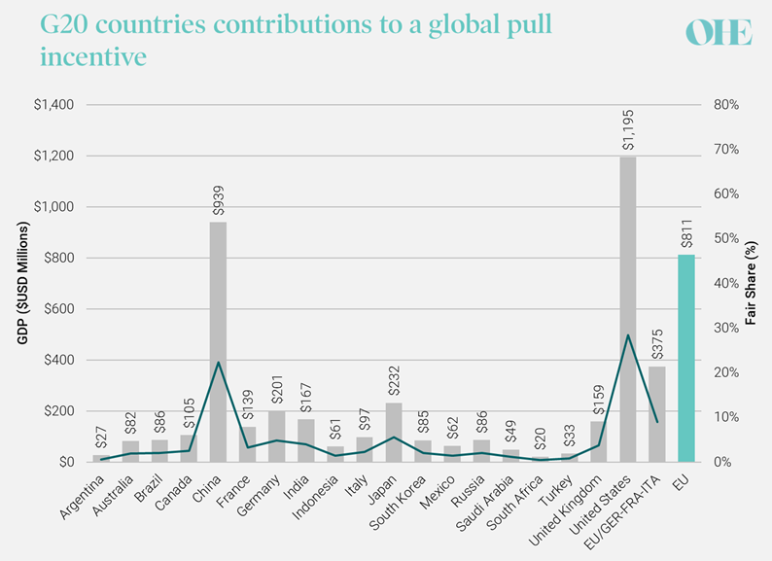

Source: World Economic Outlook Database April 2022 [3,6]
Source: World Economic Outlook Database April 20223,6
Figure 1: G20 countries' contributions to a global pull incentive based on their shares of IMF GDP estimates in 2022 and the Outterson [3] estimate for a global pull incentive.
Source: World Economic Outlook Database April 20223,6
Note: Vertical bars represent each country's individual contribution; Line represents each country's share in percentages; Green bar represents the EU contribution, including Germany, France, and Italy; To avoid double-counting the GDP of Germany, France and Italy has been subtracted from the EU's total GDP (EU/GER-FRA-ITA).

Are the UK and the US pulling their weight?

Using the G20 GDP rule we can judge whether the planned contributions of the UK and the US meet their fair share. The NICE-NHS England AMR pilot pays up to £100m, or $134m using the latest exchange rate. This roughly equates to the best estimate of the UK's G20 GDP fair share of the $4.2 billion global pull incentive of roughly $159m. The PASTEUR Act in the US, if passed in its current form, would deliver the US's fair share of the global total of roughly $1.2 billion.

If the focus were put in the G7 countries, the same method will produce shares of around $315 million and $2.4 billion for UK and the US respectively. While PASTEUR in the US would potentially cover the G7 share of the US, the UK contribution would fall short. The contribution of the three EU countries within the G7 (Germany, France, and Italy) should add up to more than $850 million.

The EU has an important role to play

Attention is now turning to how the EU will proceed. The EU, through the EU-JAMRAI initiative has committed to design and trial a pull incentive although the total size is not known [7]. It has considered many proposals for a delinked pull incentive mechanism including a joint procurement mechanism, patent extensions and transferable exclusivity vouchers [7].

Whatever the mechanism selected, there are two alternative ways to organise the EU contribution. It could either be coordinated centrally with a supranational initiative through the European Commission, or each Member State could contribute individually and independently within an agreed EU-wide legal requirement for national action [8]. A centrally organised initiative, while politically complex to negotiate, has the benefit of sending a stronger signal to industry.

Can priority setting take place at a global level?

With lots of different countries deciding on the best way to proceed, some form of international coordination is needed to ensure individual actions add up to a sufficient global pull. Cooperation also prevents industry from only investing in those pathogens highly valued in high-income countries while global priority pathogens remain underfunded. Setting priorities on the kinds of antibiotics that should qualify for a pull mechanism can be made at a global level for example by prioritising products that target an agreed list of priority pathogen such as those compiled by the World Health Organisation or the Centres for Disease Control and Prevention (CDC) [1].

Scientific collaboration can also go further to define a common target product profile (TPP) to give developers more clarity of the kind of products that will be rewarded through pull incentive mechanisms [1]. AMR specific value frameworks for value assessment like the STEDI framework -referring to spectrum, transmission, enablement, diversity and insurance value- used in the NICE-NHS England model, are critical for rewarding products with additional value [10].

The priorities will change over time. As incentives arise and industry responds by tackling the highest priorities on the list, this priority list should be updated. This requires a mechanism for taking addressed targets off the list and also allowing the future re-entry of once dropped targets as they develop resistance again.

Where does that leave us for the future?

The leadership to take steps to combat AMR shown by England is a start, but other countries must follow. The EU in particular has an important role to play and is moving towards a proposal which, if adopted, would send a strong signal to the industry that antibiotics will be rewarded. It may be a different pull incentive to the subscription model, such as a market entry reward or a transferable exclusivity voucher [3]. As long as the total global value of pull incentives is sufficiently large that industry responds, then flexibility for countries to select the model that works best for them will promote efficient policy making.

The Economics of Antibiotics blog series

In this four-part series, we discuss the economics of antimicrobial resistance to understand the relevance of the NICE-NHS England AMR model and explore the questions that remain about the delinked model:
- Part 1: Why NICE and NHS England are Testing an Innovative HTA and Payment Model to Tackle AMR
- Part 2: Value Assessment within the NICE-NHS AMR Pilot
- Part 3: Creating a Healthy Global Market for New Antibiotics
- Part 4: What Does the Antibiotics Market of the Future Look like?

References

- BCG, 2022. Incentivizing Innovation to Tackle Antimicrobial Resistance. [online] Available at: https://www.bcg.com/en-nor/publications/2022/model-for-tackling-antimicr... [Accessed 30 Jun. 2022].
- Dutescu, I.A. and Hillier, S.A., 2021. Encouraging the Development of New Antibiotics: Are Financial Incentives the Right Way Forward? A Systematic Review and Case Study. Infection and Drug Resistance, Volume 14, pp.415–434. 10.2147/IDR.S287792.
- Outterson, K., 2021. Estimating The Appropriate Size Of Global Pull Incentives For Antibacterial Medicines: Study examines global antibacterial pull incentives. Health Affairs, 40(11), pp.1758–1765
- G7 Finance Ministers, 2021. G7 Finance Ministers’ Statement on Actions to Support Antibiotic Development. [online] Available at: https://assets.publishing.service.gov.uk/government/uploads/system/uploa... [Accessed 16 Aug. 2022].
- Danzon, P., Towse, A. and Mestre-Ferrandiz, J., 2015. Value-based differential pricing: Efficient prices for drugs in a global context. Health Economics, 24(3), pp.294–301.
- International Monetary Fund, 2022. World Economic Outlook Database. [online] Available at: https://www.imf.org/en/Publications/WEO/weo-database/2022/April [Accessed 08 Sep. 2022].
- Årdal, C., Lacotte, Y. and Ploy, M.-C., 2021. Improving access to essential antibiotics. EU-JAMRAY, p.7.
- Towse, A., Hoyle, C.K., Goodall, J., Hirsch, M., Mestre-Ferrandiz, J. and Rex, J.H., 2017. Time for a change in how new antibiotics are reimbursed: Development of an insurance framework for funding new antibiotics based on a policy of risk mitigation. Health Policy, 121(10), pp.1025–1030.
- Craven, M., Sabow, A., Van der Veken, L. and Wilson, M. (2021). Not the last pandemic: Investing now to reimagine public-health systems. [online] Available at: https://www.mckinsey.com/industries/public-and-social-sector/our-insight... [Accessed 9 Sep. 2022].
- Outterson, K. and Rex, J.H., 2020. Evaluating for-profit public benefit corporations as an additional structure for antibiotic development and commercialization. Translational Research, 220, pp.182–190. 10.1016/j.trsl.2020.02.006.

The Economics of Antibiotics - Part 4: What Does the Antibiotics Market of the Future Look Like?
Article by: Isobel Firth, Mikel Berdud, Simon Brassel, Adrian Towse and Lotte Steuten
Wednesday, 12 October 2022

https://www.ohe.org/news/economics-antibiotics-part-4-what-does-antibiotics-market-future-look

This article was commissioned by Pfizer Inc. Content was written by OHE Consulting Ltd with technical review from Pfizer Inc.

The previous three blogs explained why market failure means we are lacking new antibiotics, how the UK is taking the lead to overcome that market failure with a Netflix-style subscription payment model for antibiotics, and what other G20 countries need to do to stimulate antibiotic development. In this fourth and final blog in our AMR series, we set out a positive scenario for tackling antibiotic resistance, and contemplate other possibilities.

International collaboration prevails

If the US pull incentive mechanism is implemented through the PASTEUR Act, the EU develops a pull incentive for antibiotics and the G7 commitments to implementing pull incentives are realised then a strong signal will be sent to companies that their investment in the development of antibiotics will be rewarded [1]. Over time, evidence will accumulate that volume-delinked payment models better align incentives for stewardship and innovation than traditional volumed-linked models. Either individually or in collaboration, enough countries will pay for antibiotics using delinked payment models to meet the global pull incentive needed to bring antibiotics to market.

Collaboration to secure a large enough economic incentive is necessary but not sufficient. International cooperation is also needed to agree and update priority lists of the most needed and most valuable antibiotics to ensure that research is focussed on on international priorities instead of local ones [2]. Importantly, it cannot take each country another 10 years to implement their version of the best delinked solution. Action is needed now.

A sustainable antibiotic market is developed

R&D investment will be stimulated in the short term as more countries become involved in a global pull incentive. A healthy antibiotics market has, however, to be sustained in the long term, as antibiotic resistance is a natural mechanism that will continue even as new antibiotics are developed. Incentives for continued investment are therefore vital.

We will learn with experience which pull mechanisms are most effective at providing the incentives needed. In our view, an incentive mechanism has a better chance of stimulating a long-term market for antibiotics if rewards are linked to the value of antibiotics developed. By linking payment to value, companies will be incentivised to develop the highest value product possible to address increasing resistance to existing treatments.

As described in the previous blogs, the development of value frameworks that are feasible to implement is a vital piece of the jigsaw for incentivising more effective new drugs. There are different mechanisms to link value assessment to a pull reward, and not all of them require a full value assessment like the one conducted by NICE for the NICE-NHS AMR model [3]. While this model has shown that implementation of the STEDI framework is possible, other countries will have their own approaches to implementing STEDI frameworks [4].

Low- and middle-income countries have reliable access to antibiotics

The discussion so far has focussed on the actions of a small number of the world’s richest countries. Yet antibiotic resistance is likely to disproportionately impact the majority of the world’s population living in low- and middle-income countries (LMICs)5. The World Health Organisation (WHO), among others, has signalled the importance of ensuring LMIC countries have access to both existing and novel antibiotics, while stewardship is protected6.

Initiatives like the Global Antibiotic Research & Development Partnership (GARDP) developing treatments for drug-resistant infections, and WHO SECURE aim to support sustainable access to antibiotics for LMICs [2]. Building on this concept, organisations like GAVI and the WHO could oversee the joint procurement and supply of antibiotics using a similar model to the COVAX Facility used to purchase COVID-19 vaccines. Taking learnings from COVID-19, an access mechanism enhanced with education and other tools, including diagnostics, could ensure the appropriate use of novel antibiotics globally. Companies also have a role to play in ensuring access to novel antibiotics in LMIC countries. With combined action valuable new antibiotics could then be shared equitably around the world [2].

A bright future is not guaranteed

The bright future we paint is possible, but it is not our current trajectory. Antibiotic resistance will not overwhelm the world quickly and simultaneously in the way that COVID-19 did, causing loss of life and economic damage so visible that it compelled action from policymakers to support innovation for vaccines and therapeutics. Many call antibiotic resistance the ‘silent pandemic’ because the moment of crisis is creeping up on us mostly undetected [2]. We will only realise we should have acted sooner when hospitals are full of people with untreatable infections and the fundamentals of modern medicine, like surgery and chemotherapy, result in high death rates from infection.

Disjointed action will likely fail to prevent antibiotic resistance from increasing. Therefore, international and intergovernmental organisations like the WHO and a G20 Ministerial Health Declaration are essential to coordinating efforts across countries. Knowledge generated from countries further along in implementing pull incentives, like the UK, will help other countries design their mechanisms. Sharing knowledge of how to implement a pull mechanism is particularly crucial given their complexity and novelty. Despite the initial design hurdle, pull mechanisms such as the subscription model are today’s best strategy for building a sustainable antibiotic market in the future because they send a strong signal to developers to invest in antibiotic development.

While the pandemic exposed so painfully that nobody is safe until all are safe, it also demonstrated how joint global action can work. But it takes time and resources. While we painted a bright picture of the future, laying its foundation must start today.

The Economics of Antibiotics blog series

In this four-part series, we discuss the economics of antimicrobial resistance to understand the relevance of the NICE-NHS England AMR model and explore the questions that remain about the delinked model:
- Part 1: Why NICE and NHS England are Testing an Innovative HTA and Payment Model to Tackle AMR
- Part 2: Value Assessment within the NICE-NHS AMR Pilot
- Part 3: Creating a Healthy Global Market for New Antibiotics
- Part 4: What Does the Antibiotics Market of the Future Look like?

References
- G7 Finance Ministers, 2021. G7 Finance Ministers’ Statement on Actions to Support Antibiotic Development. [online] Available at: https://assets.publishing.service.gov.uk/government/uploads/system/uploa... [Accessed 16 Aug. 2022].
- WHO, 2022. Expanding Sustainable Access to Antibiotics (SECURE). [online] Available at: https://www.who.int/groups/secure-expanding-sustainable-access-to-antibi... [Accessed 10 Jul. 2022].
- NICE, 2022. NICE reaches important milestone in the UK’s efforts to tackle antimicrobial resistance. | News and features | News | NICE. [online] Available at: https://www.nice.org.uk/news/article/nice-reaches-important-milestone-in... [Accessed 08 Sep. 2022].
- Outterson, K. and Rex, J.H., 2020. Evaluating for-profit public benefit corporations as an additional structure for antibiotic development and commercialization. Translational Research, 220, pp.182–190. 10.1016/j.trsl.2020.02.006.
- Antimicrobial Resistance Collaborators, 2022. Global burden of bacterial antimicrobial resistance in 2019: a systematic analysis. The Lancet, 399(10325), pp.629–655.
- Access to Medicine Foundation, 2022. Lack of access to medicine is a major driver of drug resistance. How can pharma take action? [online] Available at: https://accesstomedicinefoundation.org/media/uploads/blocks/62a1d79087db... [Accessed 06 Sep. 2022].

